書籍分類

Judge a book

在這專案中我們要來研究一下是否可以從一本書的封面得知書的類別。

In this project, you will investigate whether it’s really possible to judge a book by its cover.

你需要做一個Scratch遊戲，讓你的朋友和電腦比賽從封面猜書的類別，看誰猜得比較準。

You will make a game in Scratch for a friend to compete against your computer to see who is better at guessing the genre of a book based only on its cover.

首先，需要訓練電腦辨識書的封面。

To do this, you’ll first need to train your computer to recognise book covers.



This project worksheet is licensed under a Creative Commons Attribution Non-Commercial Share-Alike License

http://creativecommons.org/licenses/by-nc-sa/4.0/

1. 搜尋網頁：<https://machinelearningforkids.co.uk/>

Go to <https://machinelearningforkids.co.uk/> in a web browser

1. 點選“**Get started**”按鈕

Click on “**Get started**”

1. 點選“**Log In**”按鈕並登入系統

*如果你沒有帳號，請你的老師幫你建立一個帳號。*

Click on “**Log In**” and type in your username and password  
*If you don’t have a username, ask your teacher or group leader.*

1. 點選上方清單中的 **”Projects”** 按鈕

Click on “**Projects**” on the top menu bar

1. 點選 “**+ Add a new project**” 按鈕

Click the **“+ Add a new project**” button.

1. 將你的專案命名為 “judge a book”並設定成辨識 “**images**”類別，點選 “**Create**”按鈕

Name your project “judge a book” and set it to learn how to recognise “**images**”. Click “**Create**”  
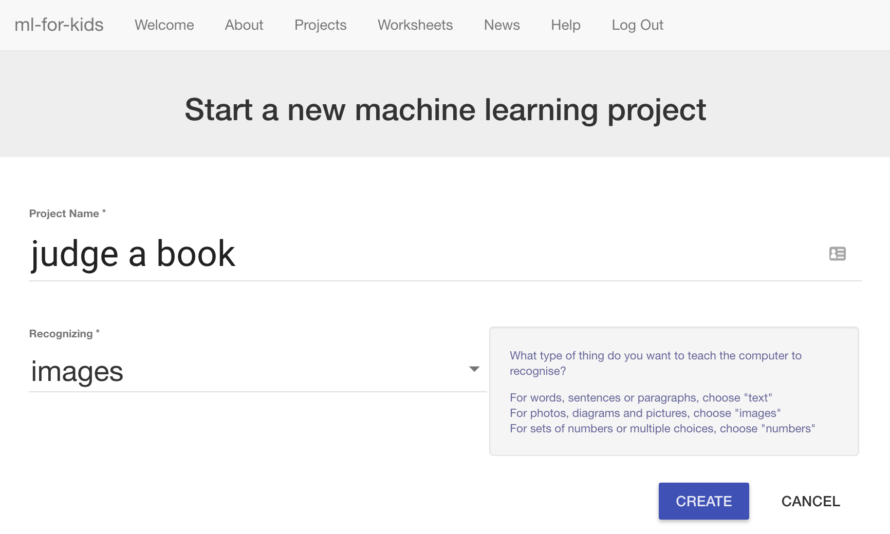

1. 你會在專案清單中看到“**judge a book**”，點選此專案

You should now see “**judge a book**” in your projects list. Click on it.  
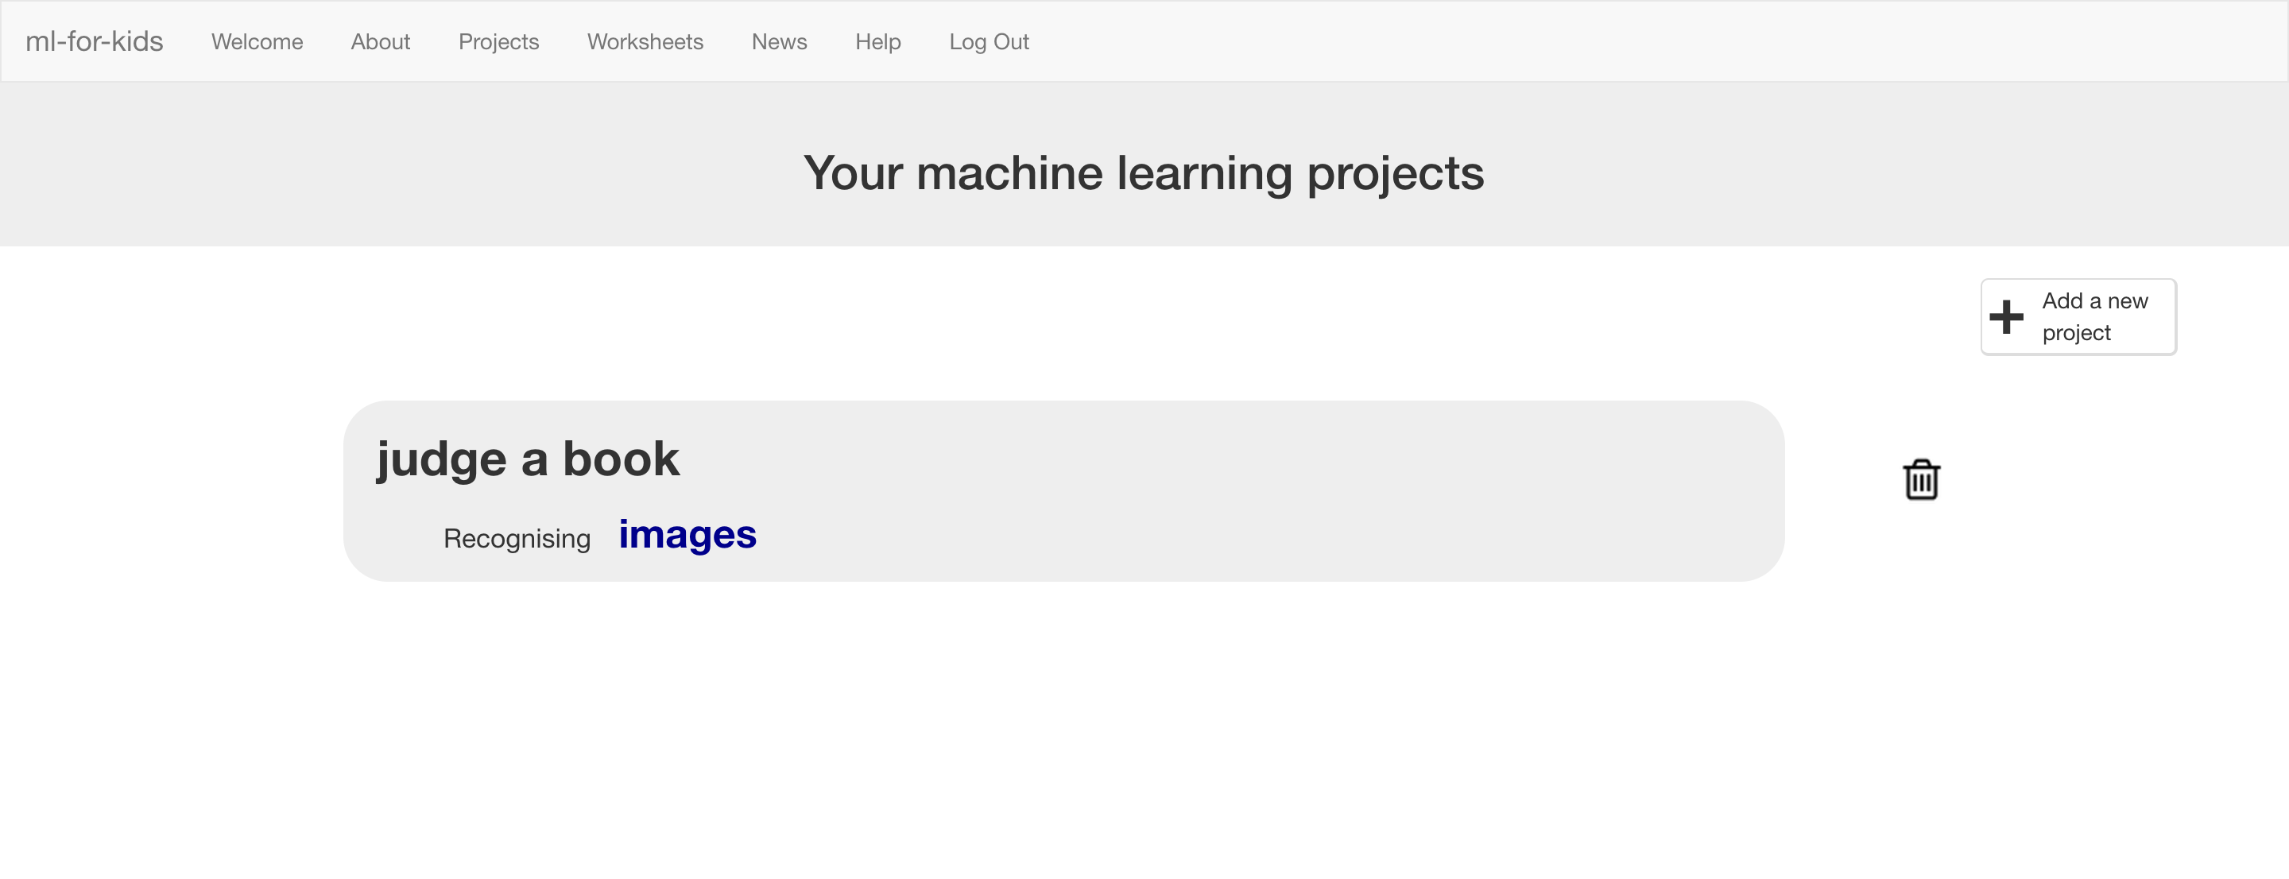

1. 點選 **”Train”** 按鈕

Click the “**Train**” button  
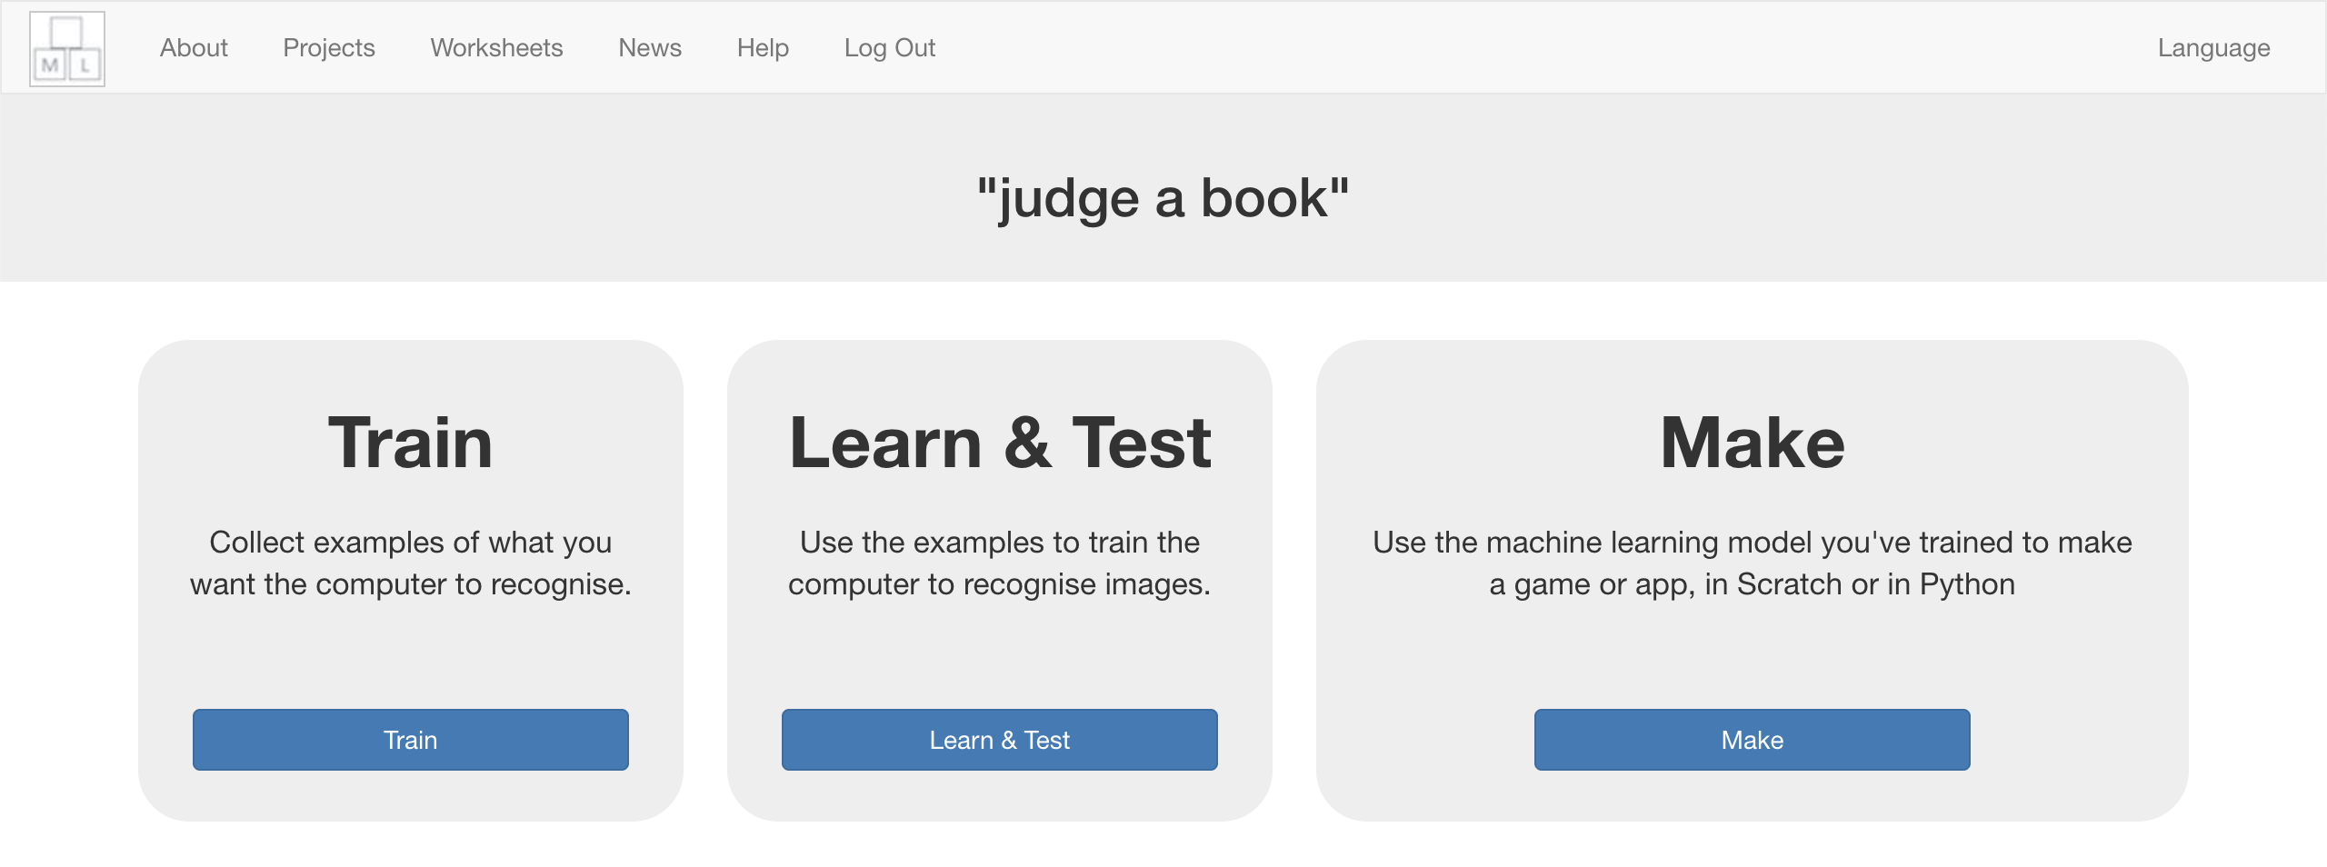

1. 挑選幾種不同類型的書

*在這份學習單中，我使用children’s、 sci fi、romance和thriller。*

*如果你想試較簡單的版本，就和我選一樣的類別，如果你很好奇想挑戰一下的話，就自己選三到五種不同的類型吧！*

Choose a few genres of books.   
*“Genre” means the type of story*.   
*For the rest of this worksheet, I’ll be using:   
 “children’s”, “sci fi”, “romance” and “thriller”.   
The project will be easier if you use these as well. But if you’re feeling adventurous, try choosing between 3 and 5 of your own instead!*

1. 點選“**+ Add new label**”幫每種類別都新增一個方框

Use the “**+ Add new label**” button to create a bucket for each genre of book you’re using.  
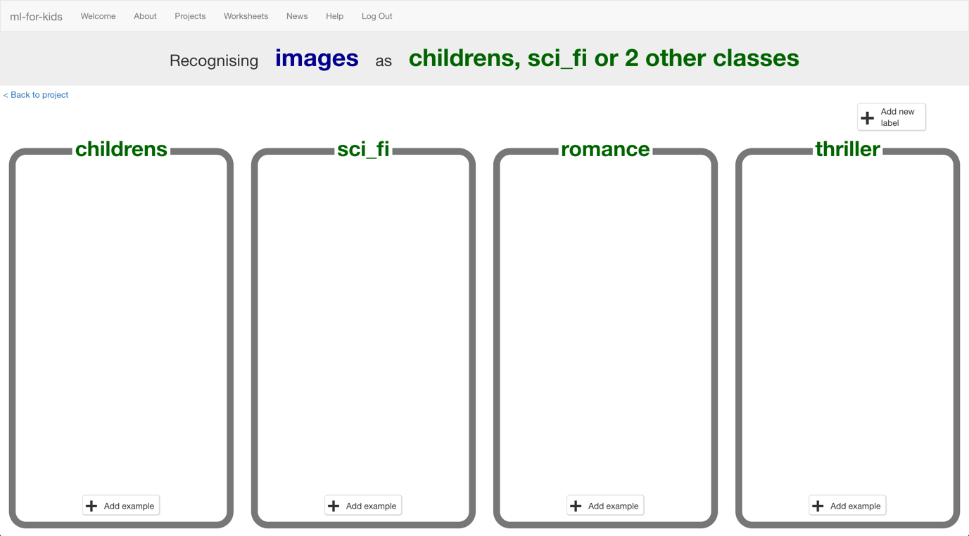

1. 開啟另一個網頁瀏覽器，調整兩個視窗大小（如下圖），在新視窗中搜尋書封面的圖片

*你需要找到有書封面圖片的網站，例如圖書館，或者是賣書的網站（像是Amazon）。最好能找到有把書籍分類整理過的網站，這樣你蒐集圖片會輕鬆些*

In another web browser window, find pictures of book covers.  
*You need to find a website of pictures of book covers. This could be a library website, or a site that sells books like Amazon. Find a site that arranges books by genre already to make it easier for you.*  
*Resize the windows so your training buckets are next to the book site.*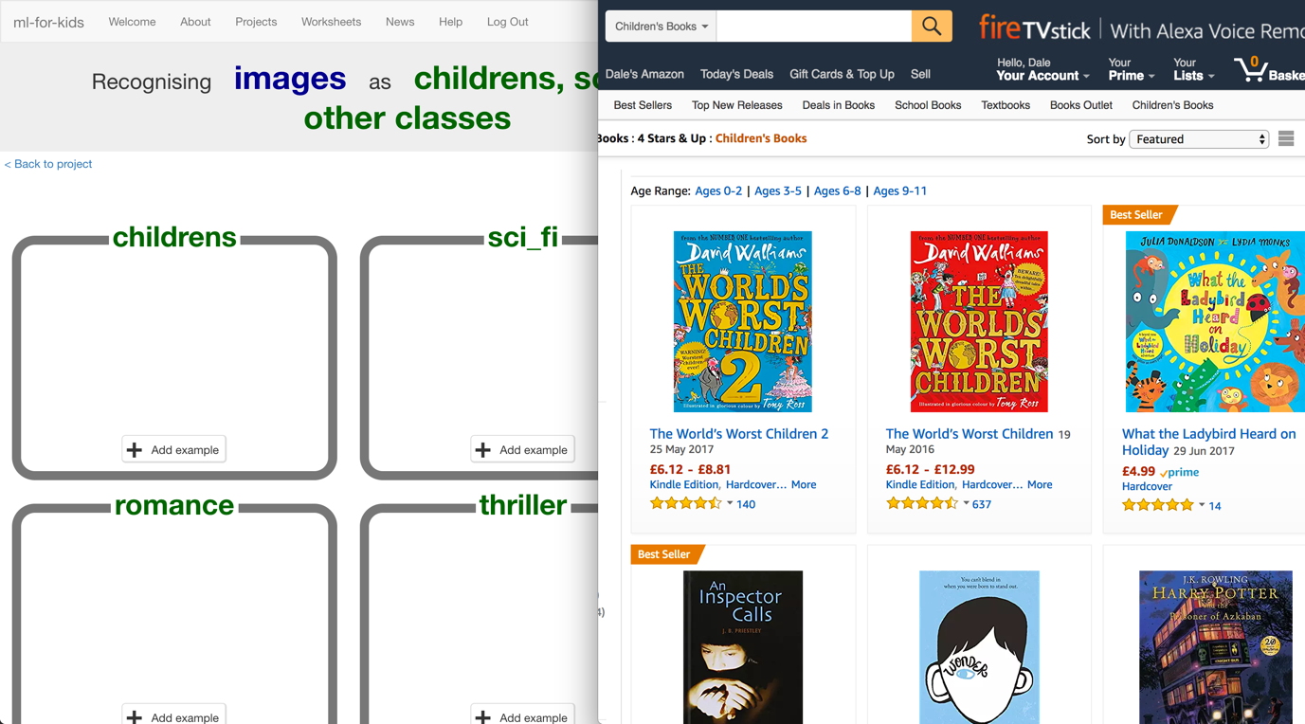

1. 依照你決定的類型蒐集書封面圖片，將好的範例圖片拖曳到方框中，每個種類大約20張範例圖片。

Find pictures of book covers in each genre you’ve chosen. Drag the best examples into the buckets in your training page.   
*Try and find about 20 examples of each genre.*   
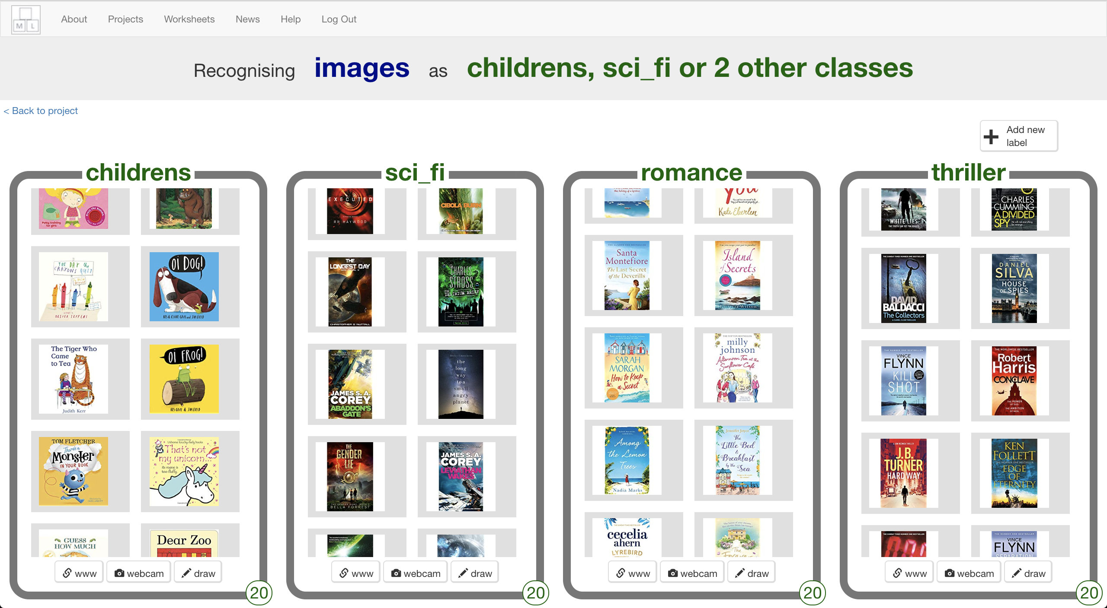

1. 將等等要用來測試的圖片儲存到電腦，每個類別的書籍都要。

*如果你不知道如何儲存圖片，請你的老師幫忙。*

*用來測試的圖片不可以和步驟12中用來訓練的圖片重複！*

Save some different pictures of book covers to your computer.   
*Ask your teacher or group leader if you’re not sure how to save a picture from a website.*   
*These are the pictures that you’ll use to test the computer with. You need some of each of your four genres. It’s important that none of these are the same as the covers you gave to the computer in step 12.*    


1. 點選“**< Back to project**”，再點選“**Learn & Test**”

Click the “**< Back to project**” link. Then click “**Learn & Test**”.

1. 點選“**Train new machine learning model**”按鈕

*當收集到夠多的範例，電腦就會從這些例子開始學習如何分辨書的封面*

Click “**Train new machine learning model**”.  
*As long as you’ve collected enough examples, the computer should start to learn how to recognise covers from the examples you’ve given to it.*  
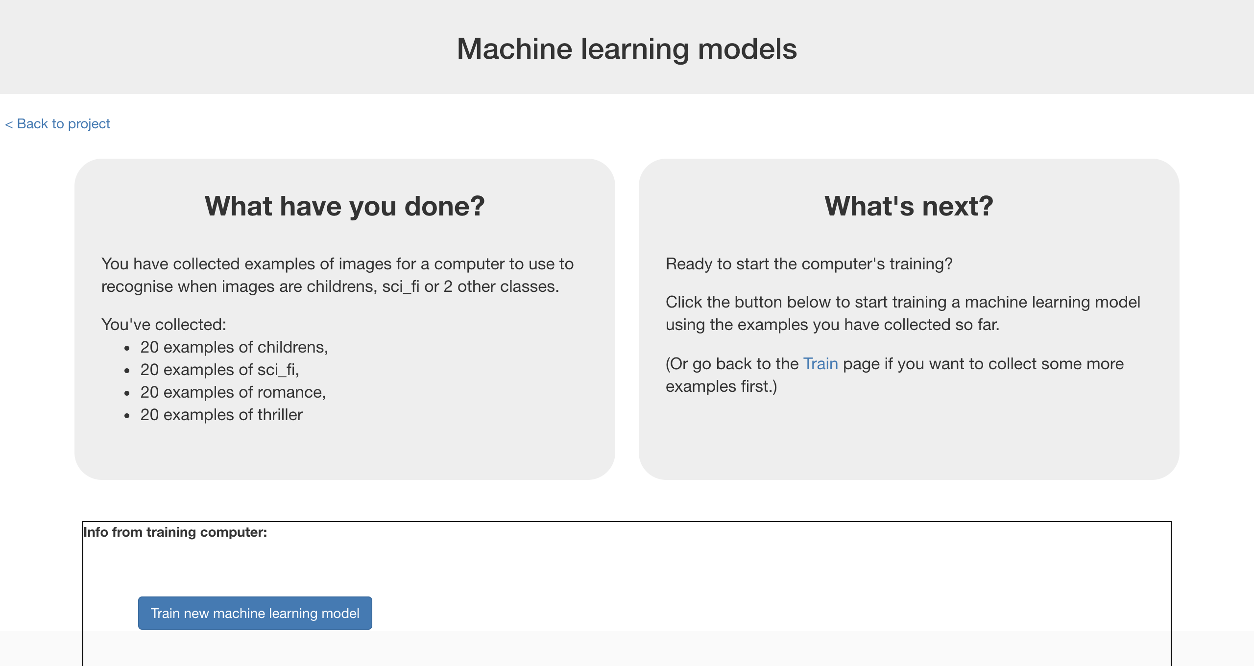

1. 等待訓練完成，這可能會需要幾分鐘的時間

Wait for the training to complete. This might take a few minutes.

1. 點選“**< Back to project**”

Click the “**< Back to project link**”

1. 點選“**Make**”按鈕，選擇“**Scratch**”並點選“**Open in Scratch**”

Click “**Make**”, then click “**Scratch**” and then click “**Open in Scratch**”  
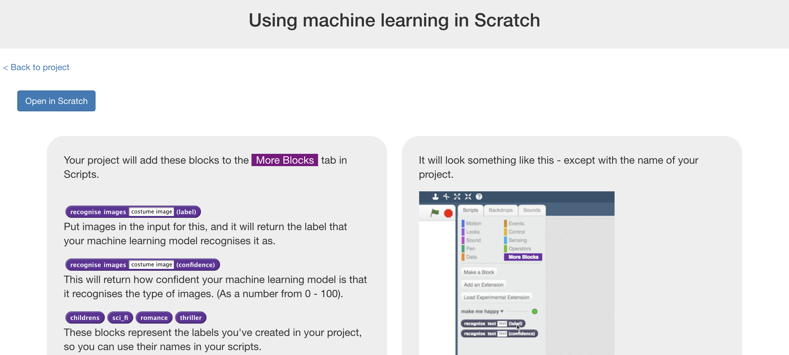

1. 你會在專案裡的『更多積木』(More blocks)區看到新積木

You should see new blocks in the “**More blocks**” section  
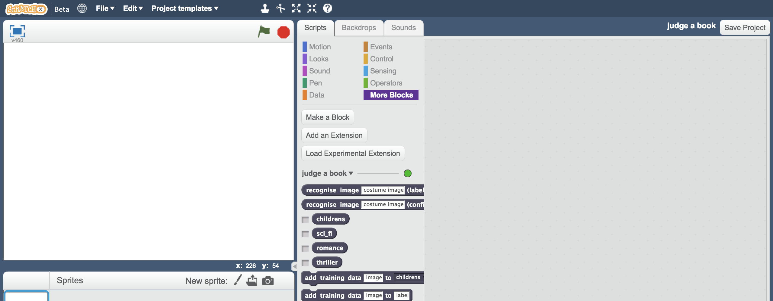

1. 開啟Judge a Book專案

點選***Project templates，***再點選***Judge a book***

Open the Judge a Book project template.   
*Click* ***Project templates*** *->* ***Judge a book*** 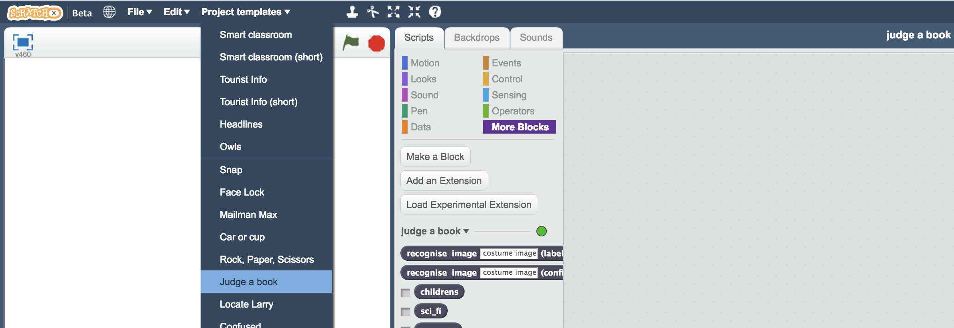

1. 如果你的書籍類別都和我一樣，可以跳至步驟26。否則的話請繼續操作，接下來幾個步驟是用來更新*Human says按鈕的*

If you used the same book genres as me, you can skip to step 26.   
*Otherwise, the next few steps update the “Human says” buttons.*  
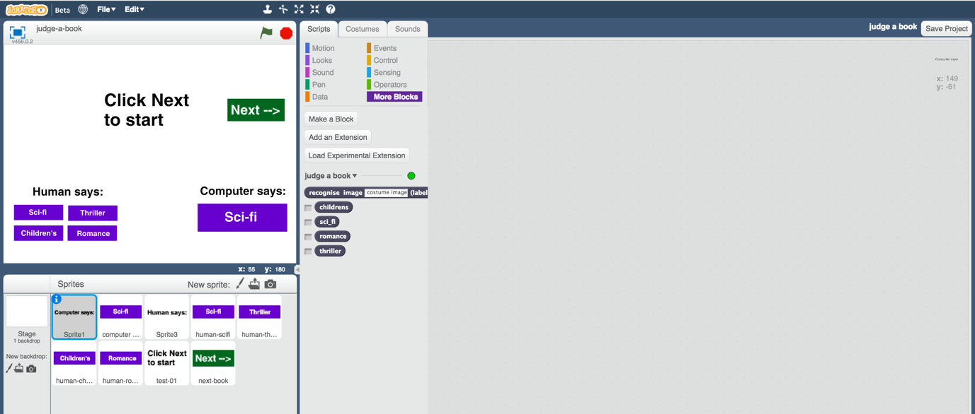

1. 選擇“human-“開頭的角色，點選『造型』

Click on one of the buttons with a name that starts “human-“   
and then click on the “**Costumes**” tab  
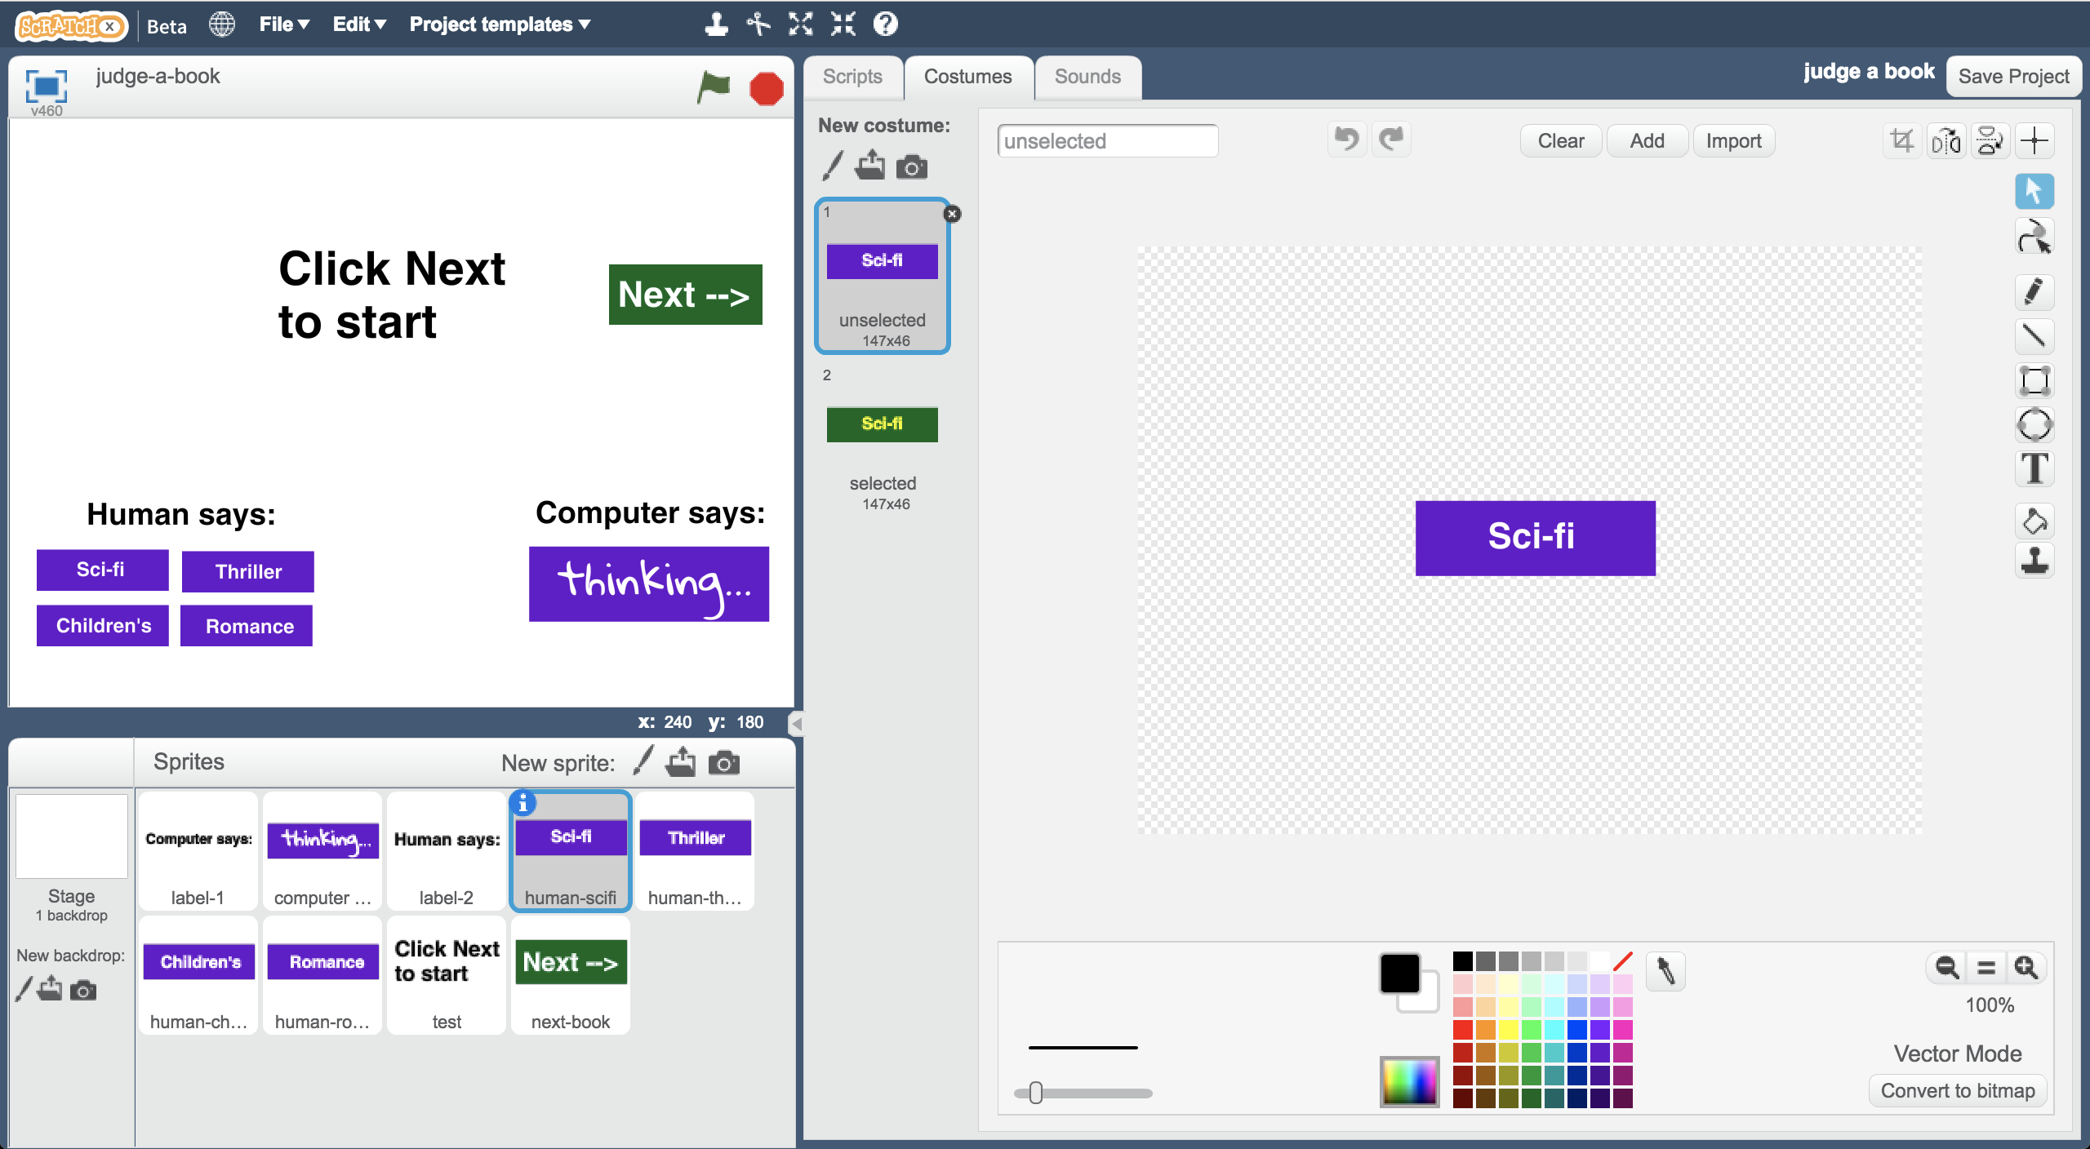

1. 將造型上的類別名稱改成你自己選的類別

Update the button graphic text with the name of a genre you chose  
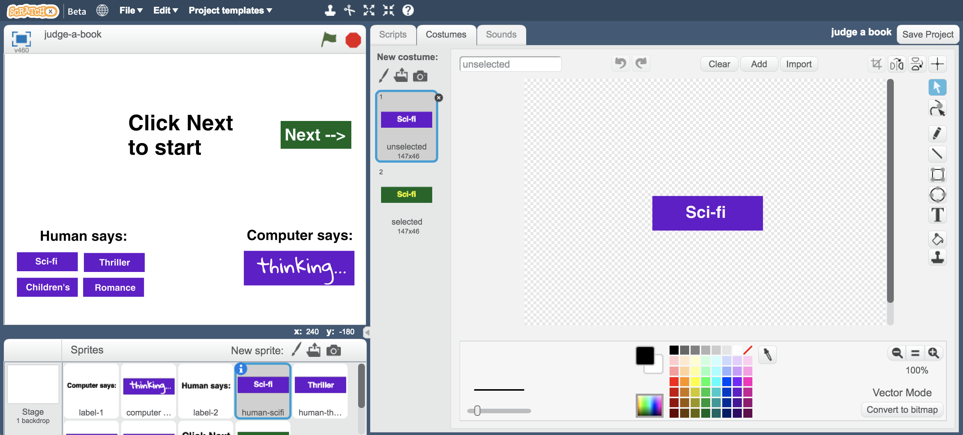

1. 點選角色左上角的藍色i標誌，更新角色名稱

Click the blue **i** icon and update the button name with the genre  
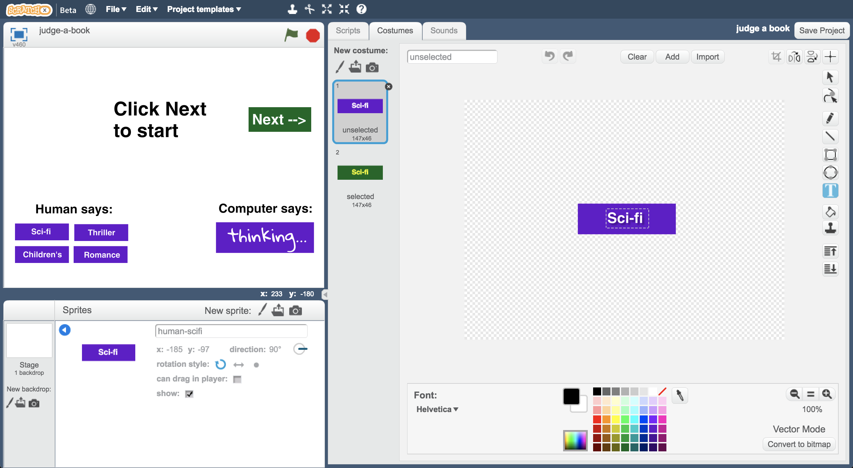

1. 重複步驟22-24，更新其他三個類別角色的造型和名稱

Repeat steps 22-24 for the other three human-GENRE buttons

1. 點選“**test**”角色，在程式區找到“**classified**”積木

Click on the “**test**” sprite and find the “**classified**” script   
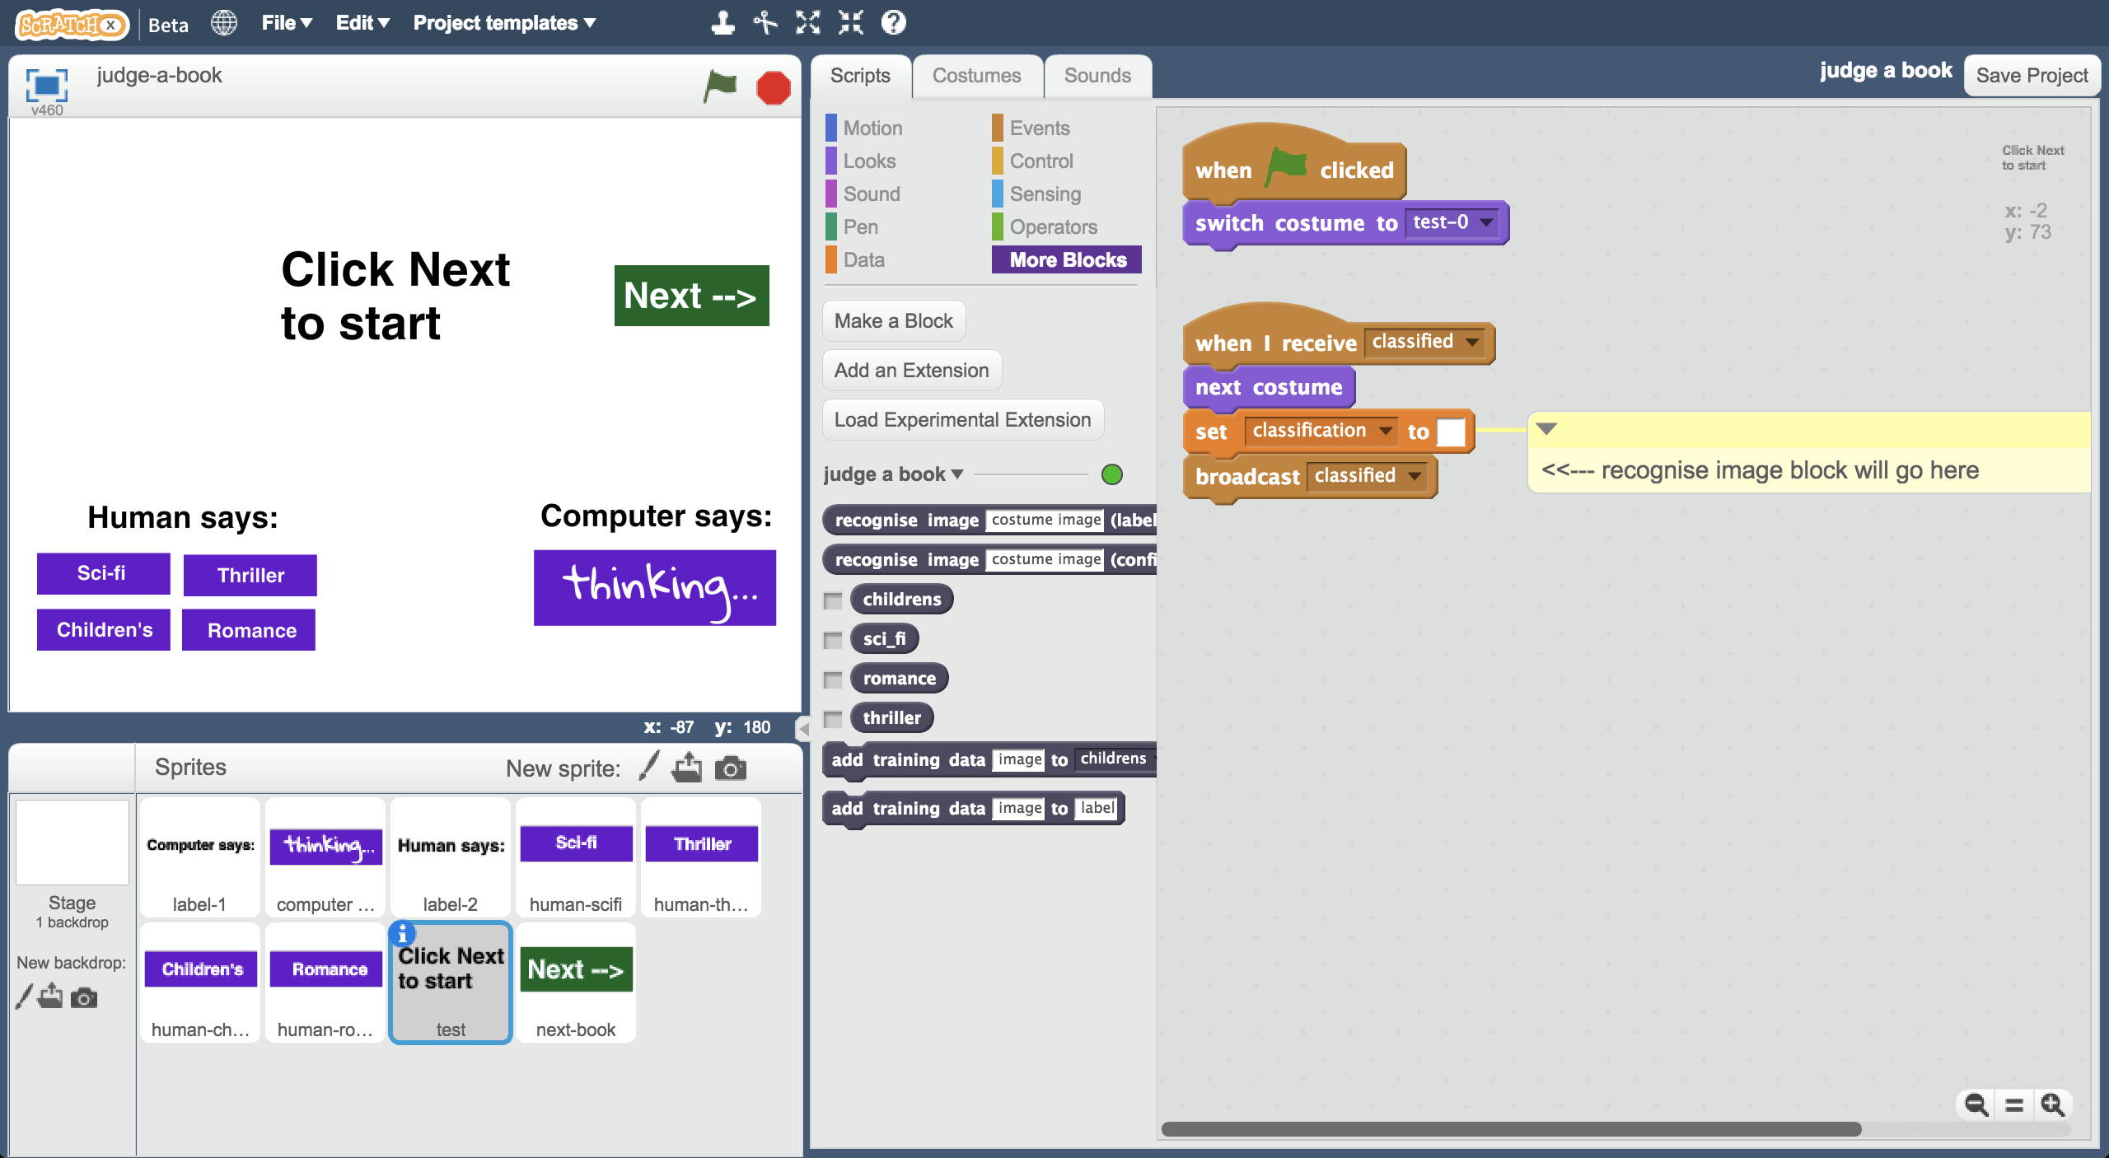

1. 加入“**recognise image (label)**”和“**costume image**”積木

Add the “**recognise image (label)**” and “**costume image**” blocks  
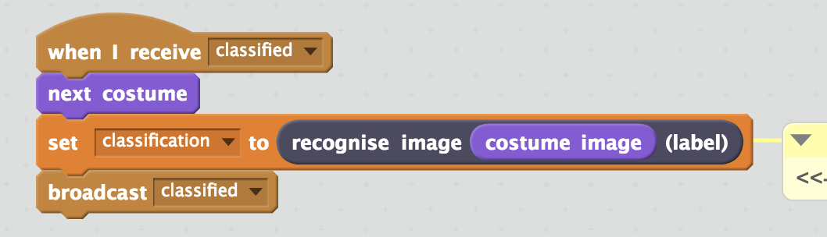

1. 點選『造型』，選擇『從檔案中上傳』

Click the “**Costumes**” tab.   
Click the “**Upload costume from file**” button with the folder icon.  
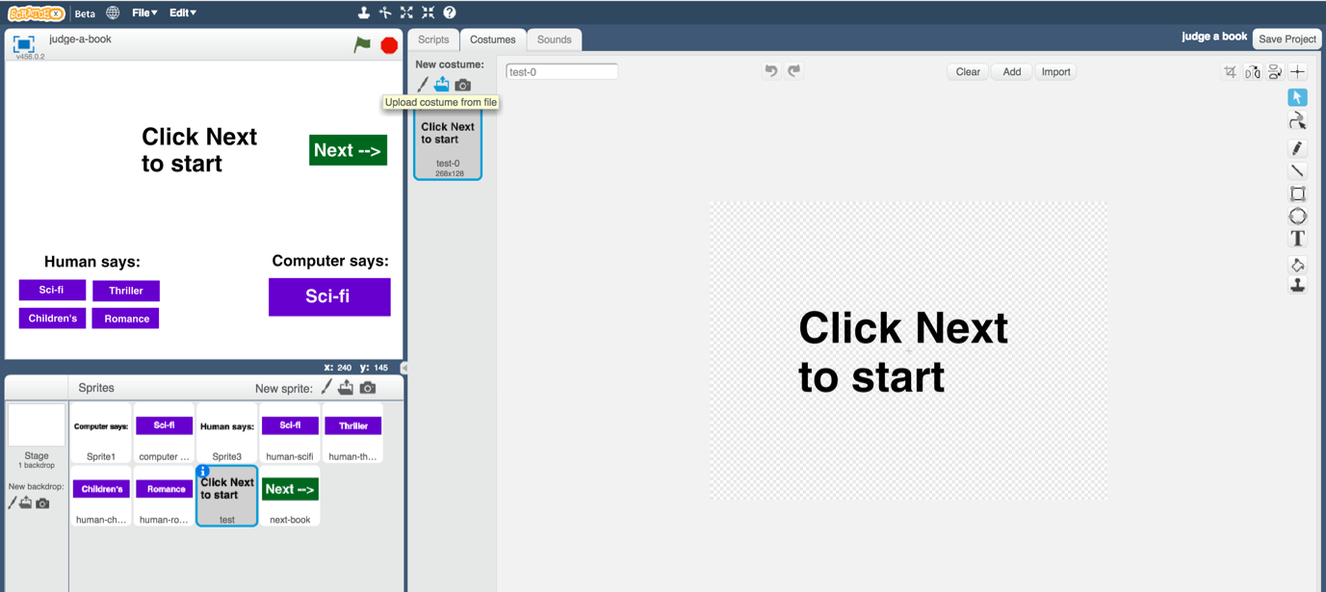

1. 上傳所有測試圖片（步驟13中儲存的圖片）

Upload all of your test images from **step 13**.  
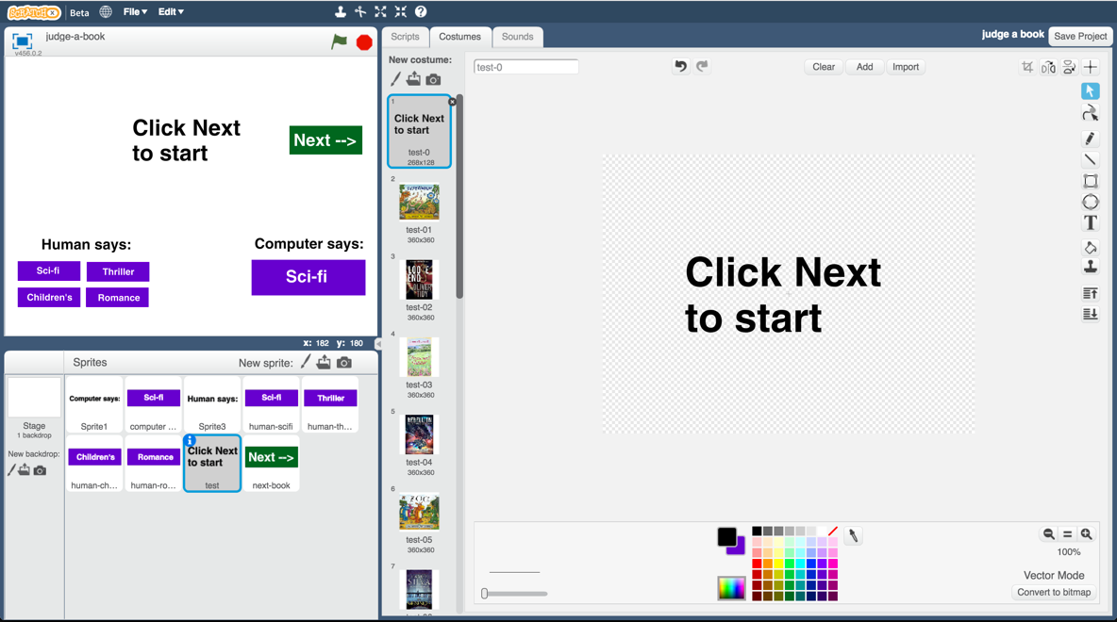

1. 點選“**computer guess**”角色

Click on the “**computer guess**” sprite  
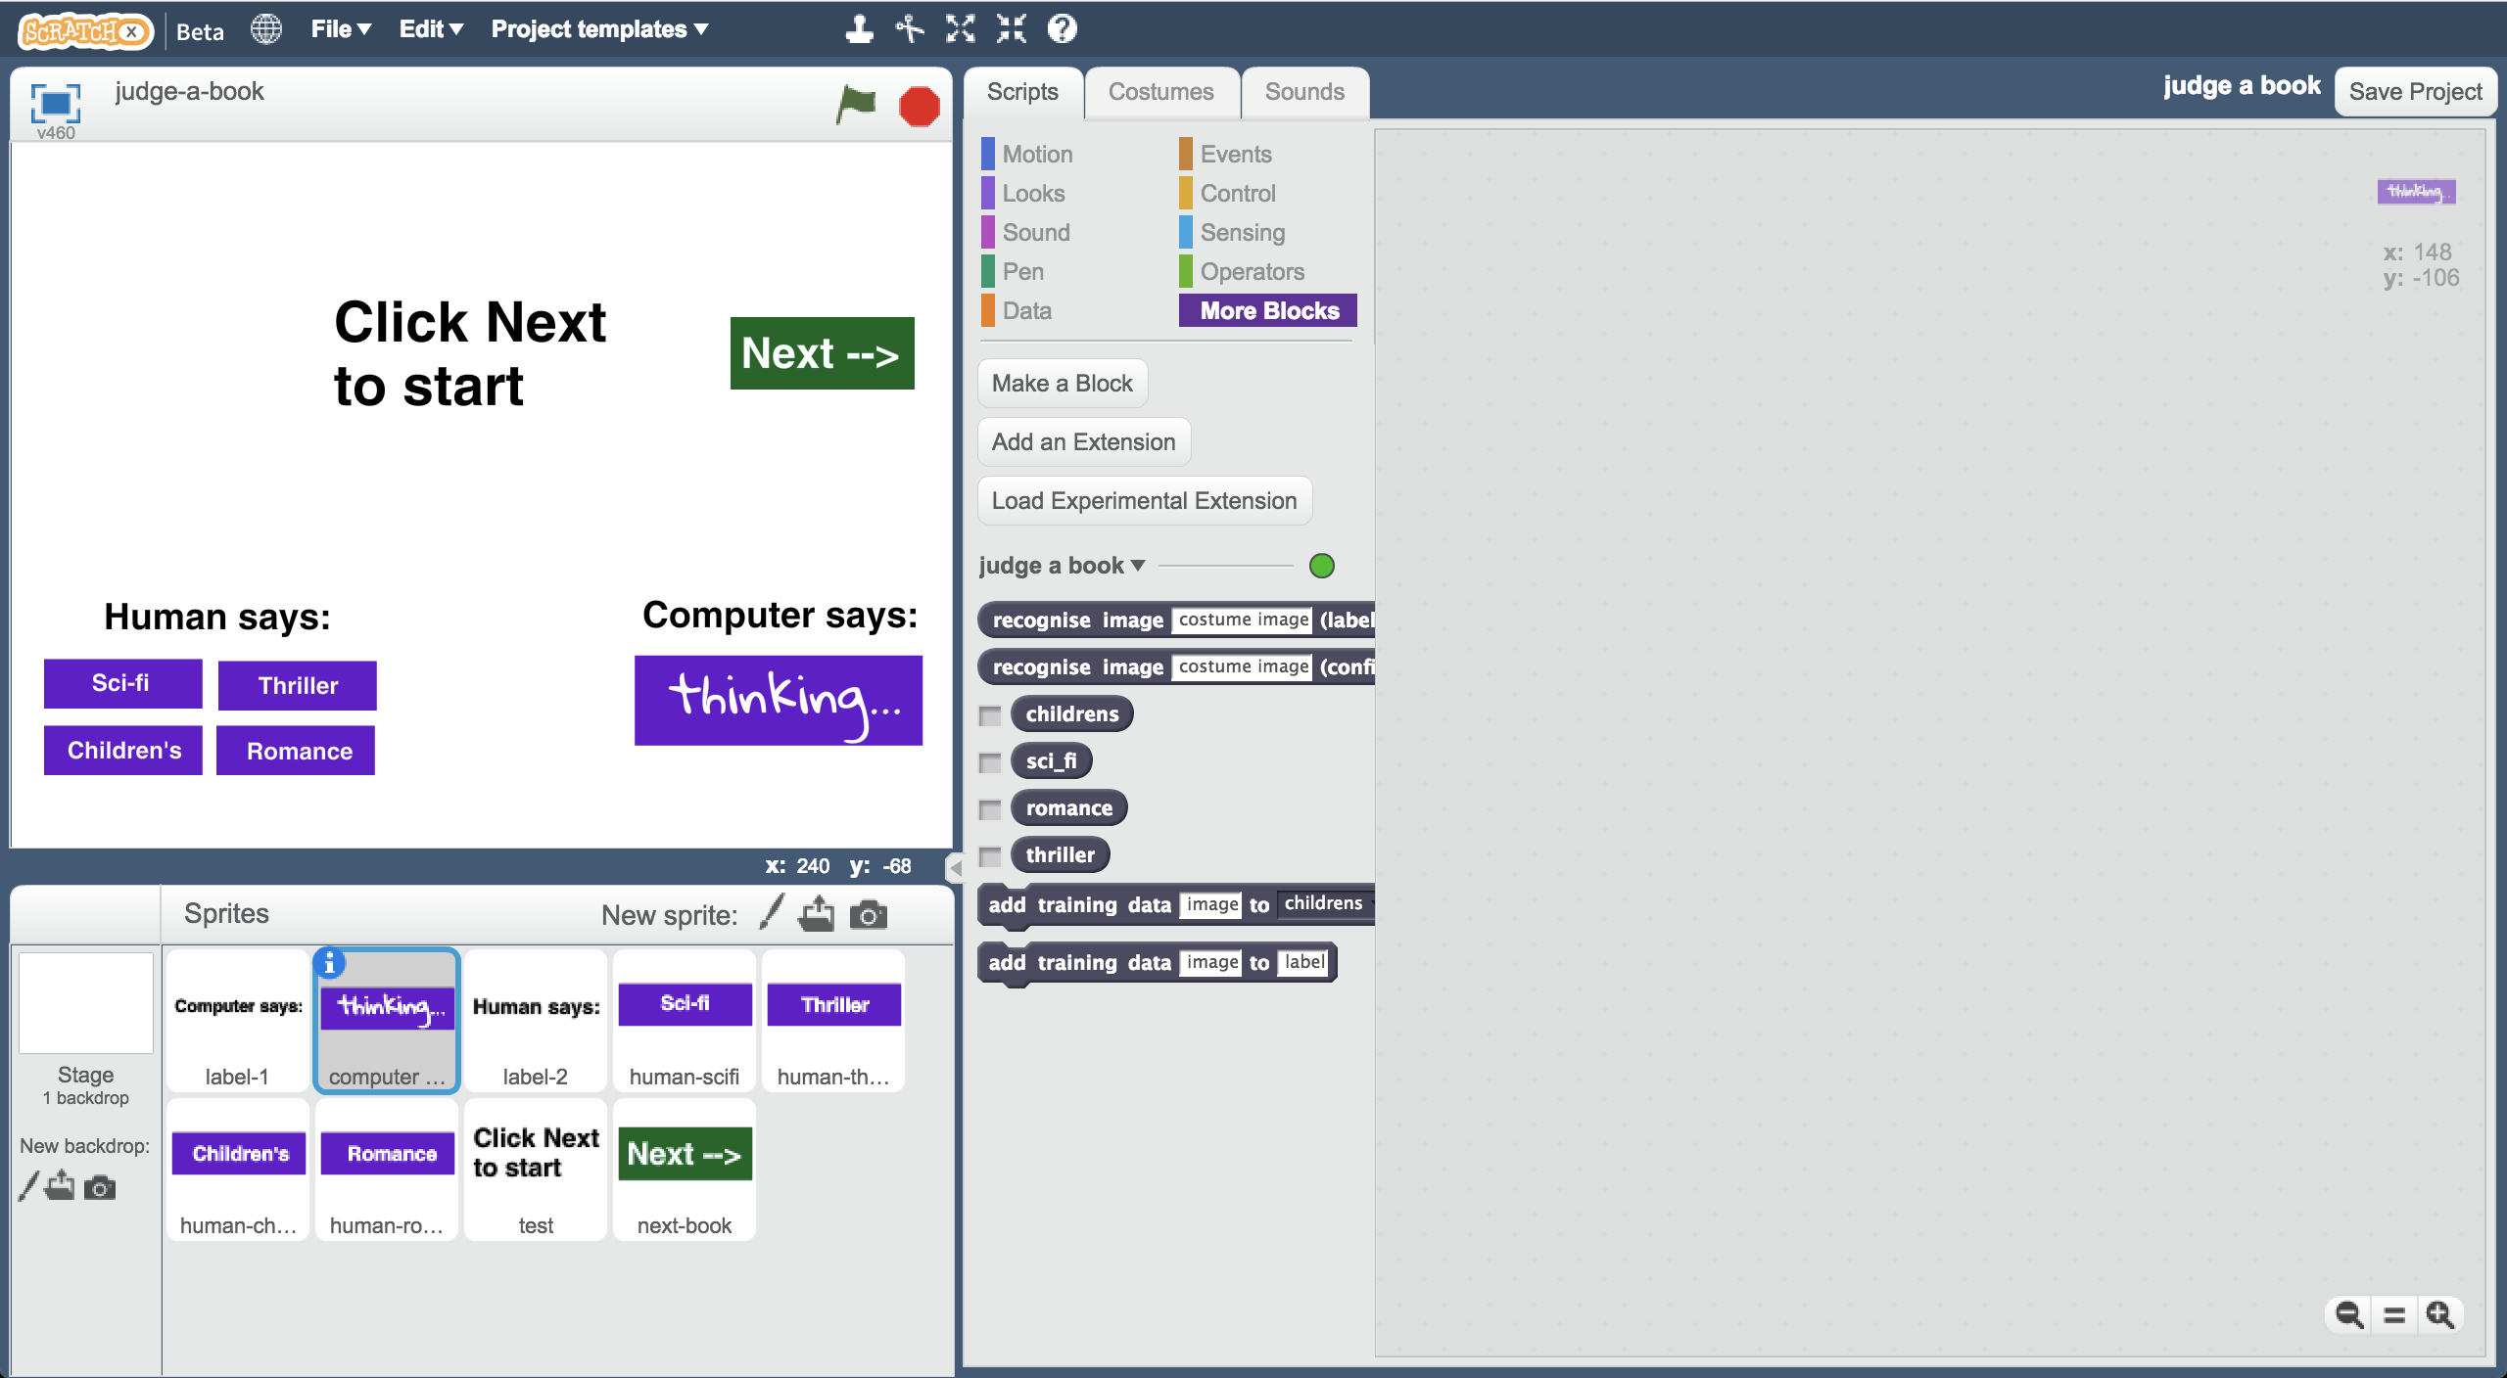

1. 拖曳程式積木（如下圖）

*這些積木是用來顯示電腦的猜測結果，如果你使用不同類別，請自行修改下面的積木內容*

Create the scripts shown below   
*This is how the computer will display its guess for each book cover you will test it with. If you’re using different book genres, update it to match.*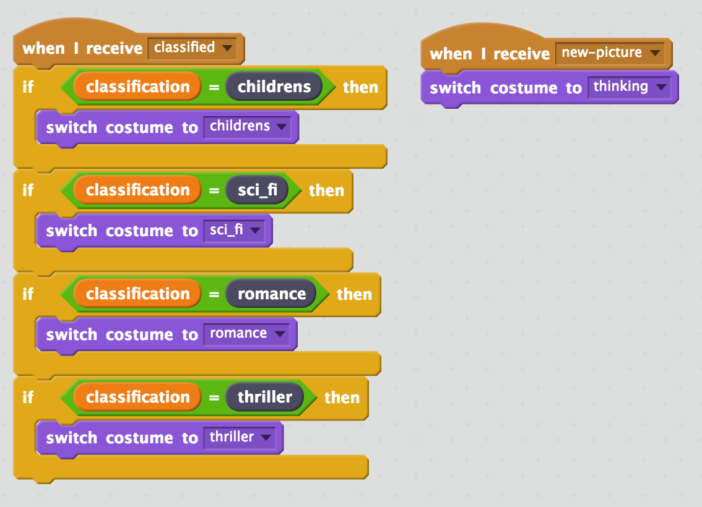

1. 測試時間到！

為了讓比賽更公平，測試圖片事先不能讓電腦知道，也不能讓你的朋友看到。

選擇全螢幕並點擊綠旗，開始比賽

*當按下Next按鈕時，受測者會看到一張書封面的圖片，要求你的朋友猜測這是屬於哪個類別的書，並點選左側“Human says”下方的按鈕作答（點擊後按鈕顏色會改變）。*

*電腦也會進行猜測並在右邊的“Computer says”顯示回答。*

*點擊“Next”後會出現下一道題目，讓你的朋友完成所有題目*

It’s time to test!  
To make this fair, you haven’t shown the test images to the machine learning computer.  
To be equal, find a friend to test this that hasn’t seen your test images.   
*Click the fullscreen icon, and then click green flag.  
  
They should click the “Next” button and they’ll see a book cover.   
  
Ask them to guess what genre book it is from the cover, and click one of the “Human says” buttons on the left to confirm their choice. (It doesn’t do anything other than look different).   
  
The computer will try and decide what genre it looks like, and display its answer under “Computer says” on the right.   
  
If they click “Next” they will move to the next book – ask them to keep going through all your test images.   
  
   
  
 *

**你完成什麼？**

**What have you done?**

你設計了一個遊戲，測試人們和電腦是不是可以從一本書的封面判斷出書的類型。

You’ve created a game that tests whether people and computers can judge a book by its cover.

你訓練了一個機器學習模型來分類圖片，電腦會從範例圖片的顏色和形狀中學到一些模式，這些模式會被拿來辨識新圖片。

Specifically, you’ve trained a machine learning model to classify pictures. The computer learned from patterns in the colours and shapes from each of the images you’ve given it. These were used to recognise new photos.

同時，你也學到如何判斷一個機器學習系統是不是個好系統：把電腦拿來跟人一起做比較，這是一個很常見的作法。

You’ve also learned about a key way that we measure how good a machine learning system is: by comparing its performance against a person. This is a common approach for tasks where the right answer isn’t already known.

有個很好的例子是語音辨識(speech recognition)，人們通常會在20個字裡漏掉1~2個字，電腦在做語音辨識的訓練時就是拿這個標準來作比較。

A good example is the task of recognising the words someone is saying : “speech recognition”. Humans miss one to two words out of every 20 we hear. Computer systems trained to recognise speech are compared against this.

**延伸活動**

**Ideas and Extensions**

現在你已經完成了這個專案，要不要試試下面的點子？或者，自己想一個？

Now that you’ve finished, why not give one of these ideas a try?

Or come up with one of your own?

**紀錄分數**

**Keeping score**

你能修改這個scratch遊戲，讓他可以紀錄分數嗎？

Can you update the Scratch game so that it keeps score?

電腦判別書籍類別的正確度是不是比人類高呢？  
Is the computer as good at recognising book genres as the people that you can get to test it?

**其他點子**

**Alternative project ideas**

除了書的封面外，也可以試試下面這些主題：

* 專輯封面：訓練電腦從專輯封面的圖片判斷專輯的類型，流行樂和rap的專輯封面有沒有不同？
* 電影海報：訓練電腦從海報判別電影的類型，動作片和時代劇的海報一樣嗎？

Instead of book covers, why not try:

* album covers – train a computer to recognise the music genre of an album from a picture of the cover – do pop music albums look different from rap albums?
* movie posters – train a computer to recognise the type of movie based on a picture of the poster – do action movie posters look different from period drama movie posters?